[ CPSC 319 ]
Software Design Specification
First Draft
Date: February 21, 2005
[ Team 4 ]

Version | Primary | Description of Version | Date
 | Author(s) |  | Completed
1.0 | Aaron Hui, Sunae Kim, Andy Kim,  Carter Lukman, John Wong, Yow-Hann Lee,  Charles Krzysik | First Draft | 02/21/2005

1. INTRODUCTION ……………………..……………………………..……….….4

  - SYSTEM OVERVIEW ………………..………………………………....……4
  - DEFINISTIONS AND ACRONYMS ……………………..……………..……4

- DESIGN CONSIDERATIONS ……………………………..…………..…….…5

2.1 ASSUMPTIONS …………………………………………………………...….5
2.2 CONSTRAINTS ………………………………………………………...……..5
2.3 SYSTEM ENVIRONMENT ……………………………………..….….….….6

- ARCHITECTURE …………………………………………………….…...……..7

3.1 OVERVIEW …………………………………………………………..……….7
3.2 RATIONALE …………………………………………………………..………7

- HIGH LEVEL DESIGN …………………………………………………..……..8

4.1 CONCEPTUAL VIEW ………………………………………………….…….8

- LOW LEVEL DESIGN ………………………………………………….….…...9

5.1 MODULE 1..N ……………………………………………………….………..9

- USER INTERFACE DESIGN ………………………………………….………50

6.1 APPLICATION CONTROL ……………………………………………….…50
6.2 SCREEN 1..N ………………………………………………………………....51

1.1 System Overview

This purpose of this project is to design and implement an online chat program. The program is intended to be used as part of an interactive live help system where a customer enters into a chat session with a customer service representative (CSR) and may ask questions in regards to a product or service.

The system will have three primary users, the customer who asks the questions, the CSR who answers the questions, and the manager who oversees the CSRs and monitors their overall performance in regards to their ability to answer questions and solve problems for the customer. After each chat session a customer may give a single digit rating to the CSR reflecting the customer’s opinion on the CSR's ability to help and if they choose, write a comment expanding on their opinions.

Each user of the system will have and account and access the system through a web page and be identified by their unique login ID and password. In order for a customer to gain access to the system they will be required to register by filling out a web application with required information. This information will be used to create a new account for the new customer.

All account and chat information will be stored on a database. The system will be developed using client/server architecture which will allow the system to be scaled up as the number of users increase.

1.2 Definitions and Acronyms

Applet - Java based code embedded within a webpage
Manager - the person who is in charge of the CSRs. A manager may operate as a CSR within the system, taking on all the responsibilities and task that a CSR may perform
Customer - the customer who engages in real time chat
Database - SQL based database containing customer information
GUI - Graphical User Interface
JDK - Java Development Kit used for compiling Java code.
JDBC Driver - A requirement for Java Database Connectivity to communicate with the
database using the database's native networking protocols.
JVM - Java Virtual Machine used during execution of Java code.
OS - Operating System
Server - A computer hosting the chat software
SQL - Structured Query Language; used for querying and updating a database
Interface - the graphical user interface or the display that encapsulates functionality
Scalable - the ability to upgrade or to reuse existing material to satisfy future requirements

2.1 Assumptions

The system is to be run on UNIX and Windows machines. The systems are assumed to have web browsers pre-installed. The list includes: Firefox, Internet Explorer 5.5 and later and Mozilla. Customers are assumed to all be connected via high speed internet. Therefore, the consumption of bandwidth by the system will not be an issue. We also assume that hardware and server components can be upgraded to satisfy the criteria for withstanding increasing demands for live customer support. Lastly, managers and CSRs are assumed to have sufficient technical training to manage the system. The manager should be trained to maintain the MySQL database of the system. Therefore, they have an understanding in database administration and how to write SQL queries.

2.2 Constraints

2.2.1 Regulatory policies
The manager is allowed to monitor all chats. CSRs will have different interfaces from customer interfaces. Also, the manager’s interface must be slightly altered from the interface of CSRs. Manager’s interface includes extended functionality. Managers are allowed to view previous chat log histories and to view current dialogues between CSRs and customers. CSRs have the ability to place hidden comments on the customer’s account for other CSRs to view. Due to the nature of a chat support system, customers are assumed to be at a novice level in computer use. Therefore, the customer interface will remain uncluttered and contain basic functionality. The customers only have the ability to view the current chat log and to send messages.

2.2.2 Reliability Requirements
The customer will be able to activate the live chat support system with the expectation that the MTBF or Mean Time between Failure is one month. In addition, the live chat support system is to be deployable from a web browser without the necessary installation of it as a standalone application. In other words, the customer should not have to download an executable file in while to install a program that provides chat support. The system shall be deployable at any time during the course of a day; this excludes periods where the system may undergo maintenance or where there may be hardware failure.

2.2.3 Criticality of the System
The chat support system provides help for customers who have questions regarding services or goods. Therefore, it is not essential for the system to be operable 100% of the time after deployment. It is not intended for circumstances in which lives depend on the proper functionality of the system.

2.2 Constraints (Continued…)

2.2.4 Safety and Security Considerations
Security regarding internet chat logs is not a priority. However, one precautionary measure should be taken. The IP addresses of customers seeking CSR’s support must be tracked. The purpose of this implementation is that CSRs do not create fraudulent customers and reap the benefits from providing more customer support. Since CSRs are to be compensated on a per customer basis, this feature is particularly vital to the integrity of the chat support system. The system connections are not required to have encryption in place. The security of the chat dialogues between CSRs and customers are projected to be minimal.

2.3 System Environment

The system will be run on UNIX and Windows machines. Also, it will be able to run on a 2.53 GHz Pentium IV with 512MB of memory and a broadband Internet connection. The server will run on a server machine, and the customers will run on individual customer machines. The system must be written in Java 1.5.xx using SWING to meet GUI requirements. And for network communication, the Java RMI protocol will be used.

3.1 Overview

The software architecture for online chat support system is based on the Client/Server architecture style. Client and Server will communicate with each other using the Java RMI protocol. The client program uses Java SWING for the UI. Clients will communicate their requests to the Server and the Server will carry them out. The system is decomposed in customer, CSR, manager, database subsystems, and all subsystems communicate through the server.

3.2 Rationale

The Client/Server architecture style is logical choice because it allows multiple users accessing on the server and centralized data such as access control, synchronization, concurrency control, and data backup.

4.1 Conceptual View

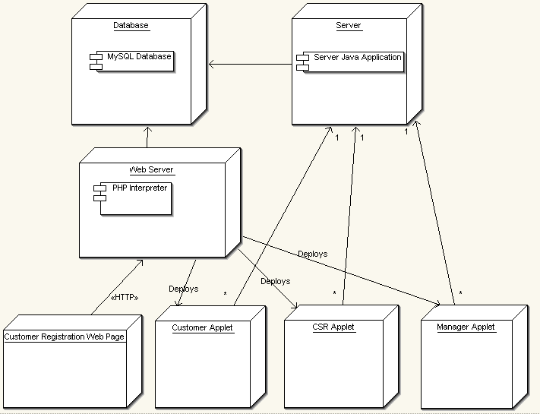

The Web Server, Database, and Server machines can all be separate or in fact be running on one machine. The web server delivers the applets via Java WebStart, launch from a web site. The customer registers new accounts from a webpage.

The Customer, CSR and Manager applets after launch establish a connection with the Server Java Application on the Server machine. The Customer Registration Web Page interacts with the Database without having to access the Server Java Application.

This section is gives a description of the low-level design of the system. It contains the break down of the over all system into it's individual subsystems and the classes that compose each subsystem. Each class and its methods are described fully and the interactions between class methods are shown in terms of subsystem interactions shown in the subsystem diagram. In addition the interaction between classes are shown through sequence diagrams that represent the primary interactions of users with the system and which classes take part in the particular interaction.

5.1 Module 1..n
- Analysis Diagram
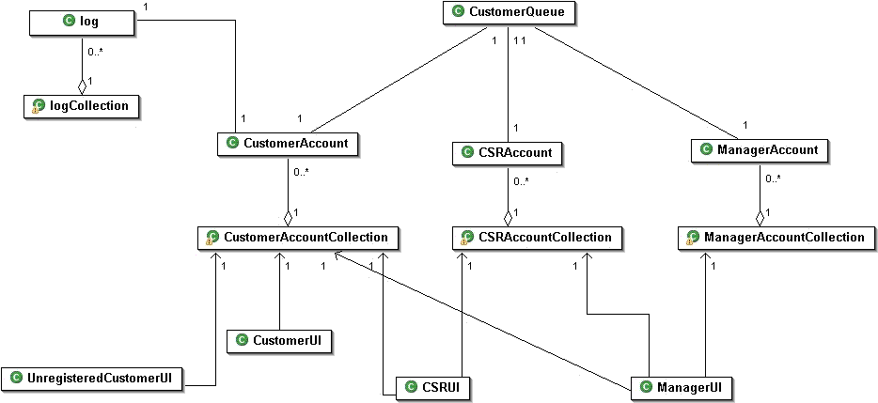
- Subsystem Diagram
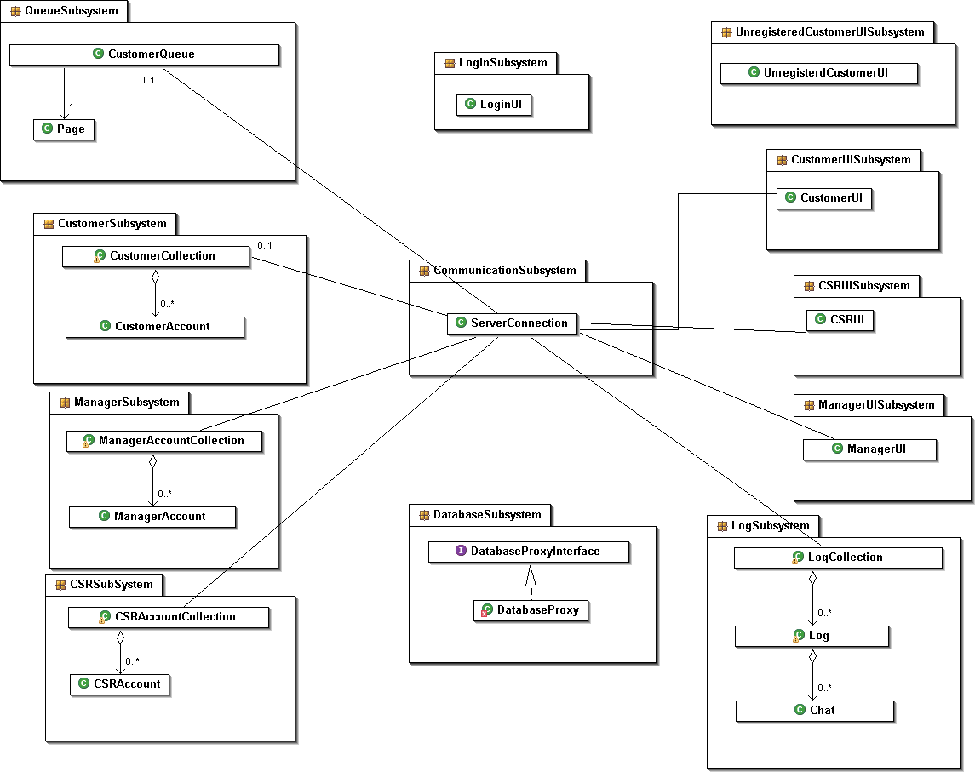

- Data Dictionary

LogSubsystem

Entity Class: LogCollection
Responsibilities | Collaborators | Attributes | Operations
Stores and maintains the logs of all the registered customers | - Log  - Chat | - logCollection | isEmpty  - returns true if there are no logs in the collection  addLog  - enables a client to add a Log to the collection  deleteLog  - enables the client to delete a Log from the collection  doesLogExist  - returns true if a Log associated with a given customer id exist in the collection  getLog  - returns the Log that is associated with the give customerId  getNumberOfLogs  - returns the number of Logs in the collection

LogCollection
Attributes:
Array CustomerLogsArray [ ]
//Stored in alphabetical order by customer account Id ??

Methods:
public boolean isEmpty();
//pre: none
//post: returns true if there are no customer chat logs in the collection

LogCollection (Continued…)
Methods:
public void addLog(Log aCustomerChatLog)
//pre: none
//post: aCustomerChatLog has been added to the collection of all //customer chat logs

public void deleteLog(String: customerId)
//pre: doesLogExist(customerId) == true;
//post: Log that belongs to a customer with id == customerId has been deleted

public boolean doesLogExist(String: customerId)
//pre: none
//post: returns true if a Log in the log collection is associated with a
//customer with id == customerId
public Log getLog(String: customerId)
//pre: doesLogExist(customerId) == true;
//post: the Log associated with customerId has been returned

public integer getNumberOfLogs()
//pre: none
//post: the number of Logs in Log Collection has been returned

Entity Class: Log
Responsibilities | Collaborators | Attributes | Operations
Stores and maintains all the chats that a single registered user has made. | - LogCollection  - Chat | - chatsCollection  - customerId | isEmpty  - returns true if there are no Chats in this log  getChats  - returns all Chats that were created in between the given dates  getCustomerComments  - returns all the customer comments associated with all the Chats in this Log  getCSRComments  - returns all the CSR comments associated with all the Chats in this Log

Entity Class: Log (Continued…)
Responsibilities | Collaborators | Attributes | Operations
Stores and maintains all the chats that a single registered user has made. | - LogCollection  - Chat | - chatsCollection  - customerId | getCustomerId  - returns the Chat associated with the given chat number  getNumberOfChatSessions()  - returns the number of Chats in this log  getCustomerId  - returns the customer id associated with this log  setCustomerId  - sets the Id of the customer associated with this Log  addChat  - adds a chat to this Log

Log
Attributes:
Array individualChatsArray [ ]
//Stored chronologically from earliest time to latest
String customerId //id of the customer this Log belongs to

Methods:
public boolean isEmpty()
//pre: none
//post: returns true if the this Log contains no chats

public Array[ ] getChats(Date: startDate, endDate)
//pre: startDate <= endDate
//post: an array that contains all chats in this Log where
// startDate <= aChat.getDate() <= endDate

public Array[ ] getCustomerComments()
//pre: isEmpty() == false
//post: an array customer comment strings arereturned

public Array[ ] getCSRComents()
//pre: isEmpty() == false
//post: an array CSR comment strings is returned

Log (Continued...)
Methods:
public int getNumberOfChatSessions()
//pre: none
//post: the number of chat sessions in this Log has been returned

public void addChat(Chat aChat)
//pre: none
//post: aChat has been added to this Log

public Chat getChat(Int: chatNumber)
//pre: 1 <= chatNumber <= getNumberOfChatSessions
//post: the chat session with Chat.getChatNumber() == chatNumber has been returned

public String getCustomerId()
//pre: setCustomerId(customerId)
//post: customerId has been returned

public void setCustomerId(String customerId)
//pre: none
//post: the owner of this Log has been set to customerId

Entity Class: Chat
Responsibilities | Collaborators | Attributes | Operations
Stores the information for a single chat session | - LogCollection  - Log | - moderator  - chatNumber  - date  - CustomerComment  - numberCustComm  - CSRComment  - NumberCSRComm  - ChatText  - chatStartTime  - chatEndTme | getModerator  - returns the Id of the moderator for this Chat  setModerator  - sets the Id for the moderator for this chat to mId  getCustomer  - gets the customerId for this chat  setCustomer  - sets the customeId  setChatNumber  - sets the unique chat number for this Chat

Entity Class: Chat (Continued…)
Responsibilities | Collaborators | Attributes | Operations
Stores the information for a single chat session | - LogCollection  - Log | - moderator  - chatNumber  - date  - CustomerComment  - numberCustComm  - CSRComment  - NumberCSRComm  - ChatText  - chatStartTime  - chatEndTme | getChatNumber  - returns the Chat Id for this Chat  setDate  - sets the Date that this chat was created  getDate  - returns the Date that this chat was created  setCustComment  - sets the customer comment for this Chat  getCustComment  - returns the customer comment associated with this Chat  setCSRComment  - sets the CSR comment for this Chat  getCSRComment  - returns the CSR comment for this Chat  addChatLine  - adds a Line of text for this Chat  getChatLine  - returns the text of a given line number  editChatLine  - sets the given chat line to be a new string S

Entity Class: Chat (Continued…)
Responsibilities | Collaborators | Attributes | Operations
Stores the information for a single chat session | - LogCollection  - Log | - moderator  - chatNumber  - date  - CustomerComment  - numberCustComm  - CSRComment  - NumberCSRComm  - ChatText  - chatStartTime  - chatEndTme | getNumberOfChatLines  - returns the number of lines of text in this Chat  setStartTime  - sets the starting time of this Chat  getStartTime  - returns the start time of this Chat  setEndTime  - sets the end time of this Chat  getEndTime  - returns the end time of this Chat  setCSRRating  - sets the rating given to the CSR in this Chat  getCSRRating  - returns the rating given to the CSR in this Chat

ChatInterface
Attributes:
String moderatorId
String customerId
int chatNumber
Date chatDate
String customerComment
String CSRComment
Array[ ] chatText

Methods:
public void setModerator(String moderatorId)
//pre: none
//post: the moderator for this chat has been set to moderatorId

ChatInterface (Continued…)
Methods:
public String getModerator()
//pre: setModerator(moderatorId)
//post: moderatorId has been returned

public void setCustomer(String customerId)
//pre: none
//post: the customer for this chat has been set to customerId

public String getCustomer()
//pre: setCustomer(customerId)
//post: customerId has been returned

public void setChatNumber(int: chatNumber)
//pre: none
//post: the id number of this Chat has been set to chat Number
public int getChatNumber()
//pre: setChatNumber(chatNumber)
//post: chatNumber has been returned

public void setDate(Date: theDate)
//pre: none
//post: the date of this Chat has been set to theDate

public Date getDate()
//pre: setDate(theDate)
//post: theDate has been returned

public void setStartTime(Stirng: sTime)
//pre: none
//post: start time for the chat has been set to sTime

public String getStartTime()
//pre: setStartTime(sTime)
//post: sTime has been returned

public void setEndTime(Stirng: eTime)
//pre: none
//post: end time for the chat has been set to eTime

public String getEndTime()
//pre: setEndTime(eTime)
//post: eTime has been returned

ChatInterface (Continued…)
Methods:
public void setCustomerComment(String: theCustComment)
//pre: none
//post: this Chat’s customer comment has been set to theCustComment

public String getCustomerComment()
//pre: setCustomerComment(theCustComment)
//post: theCustComment has been returned

public void setCSRComment(String: theCSRComment)
//pre: none
//post: this Chat’s CSR comment has been set to theCSRComment

public String getCSRComment()
//pre: setCustomerComment(theCSRComment)
//post: theCSRComment has been returned

public void addChatLine(String: chatLine)
//pre: none
//post: a line of text == chatLine has been added to this chat

public void editChatLine(int lineNumber, String newText)
//pre: 0 < lineNumber<= getNumberOfChatLines()
//post: the text on lineNumber has been changed to newText

public String getChatLine(int lineNumber,)
//pre: 0 < lineNumber<= getNumberOfChatLines()
//post: the text on lineNumber has been returned

public int getNumberOfChatLines()
//pre: none
//post: the number of lines of text in this Chat has been returned

public void setCSRChatRating(int: csrRating)
//pre: none
//post: the CSR’s rating for this Chat has been set to csrRating

public int getCSRChatRating()
//pre: setCSRChatRating(csrRating)
//post: csrRating has been returned for this Chat.

CustomerSubsystem

Entity Class: CustomerUI
Responsibilities | Collaborators | Attributes | O Operations
To provide a registered customer with an interface to access and utilize the system | - CustomerAccountCollection  - CustomerAccount custAcc | - UserName  - Password  - Email  - FirstName  - LastName | loginUserName  - logs into the system  enterCustomerQueue  - enters the customer into the chat queue to speak to a CSR or manager  sendMessage  - send message to CSR or manager  deleteChatComment  - delete comment of a chat session  viewCurrChatLog  - view current chat log  viewChatHistory  - view chat history of customer with CSRs  editOwnAccount  - change own customer account

CustomerUI
Attributes:
String password;`
String loginUserName;
String msg;
Chat theChat;
Log theLog;
CustomerAccount custAcc

CustomerUI (Continued…)
Methods:
public void loginUserName(String UserId, String password);
// pre: none
// post: customer with the associated account is connected to the server

public void enterCustomerQueue();
// pre: none
// post: customer has been entered into the chat queue

public String sendMessage(String msg);
// pre: none
// post: customer’s typed input is sent to the server

public String viewCurrChatLog();
// pre: none
// post: customer’s current chat dialogue with CSR is displayed

public Log viewChatHistory();
// pre: none
// post: customer’s chat history/log is returned

public void editOwnAccount(CustomerAccount custAcc)
// pre: none
// post: customer’s own account has been edited

Entity Class: CustomerAccount
Responsibilities | Collaborators | Attributes | Operations
To store information on the customer | - Log  - CustomerAccountCollection  - CustomerQueue | - userId  - firstName  - lastName  - phone  - email | checkUser  - authorizes user with valid userId and password  getUserID  - get customer userID  getFirstName  - get customer first name  getLastName  - get customer first name  getTelephoneNum  - get customer phone number  getEmailAddress  - get customer email address  getPassword  - get manager password  editUserID  - change manager user ID  editFirstName  - change manager first name  editLastName  - change manager last name  editTelephoneNum  - change manager phone number  editEmailAddress  - change manager email address  editPassword  - change manager password

CustomerAccount
Attributes:
String userID;
String firstName;
String lastName;
String telephoneNum;
String emailAddress;
String password;

Methods:
public Bool checkManager(String password);
// pre: none
// post: authenticates customer if the given password matches the password in the customer account

public String getUserID();
//pre: none
//post: customer userID has been returned

public String getFirstName();
//pre: none
//post: customer first name has been returned

public String getLastName();
//pre: none
//post: customer last name has been returned

public String getTelephoneNum();
//pre: none
//post: customer phone number has been returned

public String getEmailAddress();
//pre: none
//post: customer email address has been returned

public String getPassword();
//pre: none
//post: customer password has been returned

public String editUserID(String userID);
//pre: none
//post: customer user name has been changed

CustomerAccount (Continued…)
Methods:
public String editFirstName(String firstName);
//pre: none
//post: customer first name has been changed

public String editLastName(String lastName);
//pre: none
//post: customer last name has been changed

public String editTelephoneNum(String telephoneNum);
//pre: none
//post: customer phone number has been changed

public String editEmail(String email);
//pre: none
//post: customer email has been changed

public String editPassword(String password);
//pre: none
//post: customer password has been changed

Entity Class: CustomerAccountCollection
Responsibilities | Collaborators | Attributes | Operations
To maintain information regarding registered customers of the system. | - CustomerAccount  - CustomerUI | - userId  - email  - password  - firstName  - lastName  - CustomerAccountColl | addUser  - adds a new user into CustomerAccount collection  checkCustomerAccount  - check for the existence of userName  isExist  - check if there is a manager account with the associated email in the collection  AddManager  - add a new manager account into the Manager AccountCollection  deleteManager  - remove an existing manager account from the ManagerccountCollection  getAccount  - retrieve the ManagerAccount associated with the userID from the collection  getSize  - calculate the number of manager account in the collection  getArray  - return the array of all managers account in the system

CustomerAccountCollection
Attributes:
Array CustomerAccountCollection [];
// stored in alphabetical order by Customer account userName;
String userName;
String email;
String password;
String firstName;
String lastName;

Methods:
public void addUser((String FirstName, String LastName, String phone, String email, String password);
// pre: none
// post: inserts essential customer account information

public bool checkCustomerAccount();
// pre: none
// post: returns true/false regarding the existence of the customer account

public ManagerAccount getArray();
// pre: none
// post: return the array of all customer accounts in the system

Entity Class: CustomerQueue
Responsibilities | Collaborators | Attributes | Operations
To maintain the order of the customers requesting to speak with a CSR or manager | - CustomerAccount  - CSRAccount  - ManagerAccount | - QueueSize (same as numberInQueue) | isEmpty  - checks to see if the queue is empty of customers  enqueue  - adds a customer into the queue for chat request  dequeue  - pops a customer off the queue to speak with a CSR or Manager

CustomerQueue
Attributes:
int QueueSize;
String UserId;

Methods:
public bool isEmpty();
// pre: none
// post: returns true/false stating whether the queue is empty or not

public void enqueue(String UserId);
// pre: none
// post: enters a customer with their corresponding userId into the chat queue

public String dequeue()
// pre: queue is not empty
// post: pops off a customer off of the chat queue

CSRSubsystem

Entity Class: CSRUI
Responsibilities | Collaborators | Attributes | Operations
To provide a registered CSR with an interface in order to access the system | - CustomerAccountCollection  - CSRAccountCollection | - userId  - password  - name  - phone  - email  - userClass | Login  - log in the system with userId and password  Register  - a new CSR account will be created.  startChat  - invoke a chat session  endChat  - end a chat session  ViewCustomerAccount  - get all the registered customers and display  DeleteCustomer  - delete the registered customer  UpdateCustomer  - update a list of the registered customer

CSRUI
Attributes:
String userId;
String password;
String name;
String phone;
String email;
int userClass;

Methods:
public void Login(String userId, String password)
// pre: none
// post: CSR account with the associated userID and password is connected to the server

public void Register(string userId, string password, string name, string phone, string email, int userClass)
// pre: the userId doesn’t exit in the collection of user account
// post: register a new CSR in the collection of user account

public void startChat();
//pre: none
//post: a chat session in invoked

public void endChat();
//pre: none
//post: a chat session terminated

public void ViewCustomerAccount()
// pre: none
// post: display all customer account

public void DeleteCustomer( string userId)
// pre: customer userID exits in the collection of user account
// post: the chosen customer account has been deleted from the collection of user account

public void UpdateCustomer(string userId)
// pre: customer userId exits in the collection of user account
// post: the chosen customer account has been updated from the collection of user account

Entity Class: CSRAccount
Responsibilities | Collaborators | Attributes | Operations
To maintain a registered CSR’s information | - CustomerQueue  - CSRAccountCollection | - CSRId  - password | getCSRId  - get CSR Id  getPassword  - get CSR password  getName  - get CSR name  getEmail  - get CSR email  getPhone  - get CSR phone  editPassword  - change CSR password  editName  - change CSR name  editPhone  - change CSR phone  editEmail  -  checkCSR  - authorize the CSR with a valid CSRId and password.

CSRAccount
Attributes:
String userId;
String password;
String name;
String email;
String phone;

CSRAccount (Continued…)
Methods:
public string getCSRId()
// pre: none
// post: return CSR userId

public string getPassword()
// pre: none
// post: return CSR password

public string getName()
// pre: none
// post: return the name of CSR

public string getPhone()
// pre: none
// post: return CSR phone

public string getEmail()
// pre: none
// post: return CSR email

public string editPassword()
// pre: CSR usrID already exits in the collection of CSR
// post: return changed CSR password

public string editName()
// pre: CSR usrID already exits in the collection of CSR
// post: return changed CSR name

public void editPhone()
// pre: CSR usrID already exits in the collection of CSR
// post: return changed CSR phone

public void editEmail()
// pre: CSR usrID already exits in the collection of CSR
// post: return changed email

public void checkCSR()
// pre: none
// post: authenticate if the given userId and password match in the CSR account collection

Entity Class: CSRAccountCollection
Responsibilities | Collaborators | A Attributes | Operations
To maintain information about registered CSR of the system. | - CSRAccount  - CSRUI | - CSRId | addCSR  - add a new CSR into the CSRAccountCollection  deleteCSR  - delete a new CSR from the CSRAccountCollection  getCSRAccount  - retrieve the CSR account associated with CSR userId from the collection of CSR account  checkAccount  - check whether the CSRId exists or not

CSRAccountCollection
Attributes:
Array CSRAccountArray[] // stored in alphabetical order by CSR account name
String userId;
String password;
String name, phone, email;
int userClass; // 1-customer, 2-CSR, 3-manager

Methods:
public void AddCSR(string userId, string password, string name, string phone, string email, int userClass)
// pre: CSR account with the given userId doesn’t exit in the collection of CSR account.
// post: a new CSR account has been added to the collection of all CSR

public void DeleteCSR(string userId)
// pre: CSR account with the given userId exits in the collection of CSR
// post: a new CSR account has been deleted from the collection of all CSR

public CSRAccount getCSRAccount(string userId)
// pre: CSR account with the given userId exits in the collection of CSR
// post: a chosen CSR account has been returned.

public void checkAccount()
// pre: none
// post: return true if a CSR account with the given userId exits in the collection

Entity Class: CustomerQueue
Responsibilities | Collaborators | Attributes | Operations
To maintain information about customers in queue. | - CSRAccount | - customerId | getCustomer  - get next requested customer from the queue.  getNumCustomer  - get the number of customer in the queue.  enqueue  - add a customer in queue.  dequeue  - delete a customer from queue.  checkQueue  - return true if a customer in queue, otherwise return false.

CustomerQueue
Attributes:
String userId;

Methods:
public string getCustomer(userId)
// pre: none
// post: get the customer with the given userId.

public int getNumCustomer()
// pre: none
// post: get the number of customers in the queue.

public void enqueue(string userId)
// pre: none
// post: enqueue a new customer in the queue.

public void dequeue(string userId)
// pre: none
// post: dequeue an existed customer in the queue.

public boolean checkQueue()
// pre: none
// post: return true if a customer in queue, otherwise return false.

ManagerSubsystem

Entity Class: ManagerUI
Responsibilities | Collaborators | Attributes | Operations
To provide the manager with an interface in order to access the system | - ServerConnection | - emailAddress  - password  - customerAccount  - csrAccount  - managerAccount  - theChat  - theLog | Login  - log in the system  selectCustomer  -select a customer from a chat queue  startChat  - invoke a chat session  endChat  - end a chat session  addChatComment  - add a comment to a chat session  deleteChatComment  - delete comment of a chat session  addCustomerComment  - add a comment to a customer account  editCustomerComment  - edit comment in a customer account  viewCustomerComment  - view comment in a customer account  deleteCustomerAccount  - remove customeraccount from the customeraccountcollection  editCustomerAccount  - change customer account information

Entity Class: ManagerUI (Continued…)
Responsibilities | Collaborators | Attributes | Operations
To provide the manager with an interface in order to access the system | - ServerConnection | - emailAddress  - password  customerAccount  - csrAccount  managerAccount  - theChat  - theLog | viewChatLog  - open a chat log  createCSRAccount  - create a new CSR account and add it to the CSRAccountCollection  deleteCSRAccount  -remove CSR account from the csraccountcollection  editCSRAccount  - change CSR account information  createManagerAccount  - add a new manager account to manageraccountcollection  editManagerAccount  - change manager account information  deleteManagerAccount  - remove manager account from the manageraccountcollection  monitorChat  - join an ongoing chat  generateReport  - create a statistic report and open it  viewOnlineCSR  - open the list of CSR that is currently online

ManagerUI
Attributes:
String emailAddress;
String password;
String customerAccount;
String csrAccount;
String customerAccount;
String csrAccount;
Chat theChat;
Log theLog;

Methods:
public void createCSRAccount(CSRAccount csrAccount);
//pre: none
//post: csrAccount is created and added to the csrAccountCollection

public void deleteCSRAccount(CSRAccount csrAccount);
//pre: none
//post: csrAccount is deleted from the csrAccountCollection

public void editCSRAccount(CSRAccount csrAccount)
//pre: none
//post: csrAccount is changed.

public void createManagerAccount(ManagerAccount managerAccount);
//pre: none
//post: managerAccount is created and added to the managerAccountCollection

public void editManagerAccount(ManagerAccount managerAccount)
//pre: none
//post: managerAccount is changed.

public void deleteManagerAccount(ManagerAccount managerAccount)
//pre: none
//post: managerAccount is deleted from the managerAccountCollection

public String generateReport();
//pre: chats exist
//post: return the statistic report of all chats

public void monitorChat(Chat theChat);
//pre: chat is ongoing
//post: manager join a chat session in invisible mode

ManagerUI (Continued…)
Methods:
public CSRAccountarray viewOnlineCSR();
//pre: none
//post: return the array of CSR that are currently active in the system

This method is inherited from CSR class (according to the use case diagram)

public void login(string emailAddress, string password);
//pre: none
//post: manager account with the associated email is connected to the server

public void selectCustomer();
//pre: none
//post: a customer from the chat queue is selected

public void startChat();
//pre: none
//post: a chat session in invoked

public void endChat();
//pre: none
//post: a chat session terminated

public void addChatComment(Chat theChat, String theComment);
//pre: none
//post: comment is added to the log of a chat

public void deleteChatComment(Chat theChat);
//pre: none
//post: comment is deleted from the log of a chat

public void addCustomerComment(Chat theChat, String theComment);
//pre: none
//post: comment is added to the log of a chat

public void editCustomerComment(Chat theChat);
//pre: none
//post: comment is deleted from the log of a chat

public string viewCustomerComment(Chat theChat);
//pre: none
//post: return the comment of both CSR and customer on a particular chat

ManagerUI (Continued…)
Methods:
public string editCustomerAccount(CustomerAccount customerAccount);
//pre: none
//post: customerAccount is changed
public void deleteCustomerAccount(CustomerAccount customerAccount);
//pre: none
//post: customerAccount is deleted from the customerAccountCollection

public string viewChatLog(Log theLog);
//pre: none
//post: return the chat log.

Entity Class: ManagerAccount
Responsibilities | Collaborators | Attributes | Operations
To maintain a manager information | - ManagerAccountColl | - userID  - firstName  - lastName  - telephoneNum  - emailAddress  - password | ManagerAccount  - a constructor to create a new manager account  getUserID  - get manager userID  getFirstName  - get manager first name  getLastName  - get manager first name  getTelephoneNum  - get manager phone number  getEmailAddress  - get manager email address  getPassword  - get manager password  editUserID  - change manager user ID  editFirstName  - change manager first name

Entity Class: ManagerAccount
Responsibilities | Collaborators | Attributes | Operations
To maintain a manager information | - ManagerAccountColl | - userID  - firstName  - lastName  - telephoneNum  - emailAddress  - password | getLastName  - get manager first name  getTelephoneNum  - get manager phone number  getEmailAddress  - get manager email address  getPassword  - get manager password  editUserID  - change manager user ID  editFirstName  - change manager first name  editLastName  - change manager last name  editTelephoneNum  - change manager phone number  editEmailAddress  - change manager email  editPassword  - change manager password  checkManager  - authorize the manager with a valid userID and password

ManagerAccount
Attributes:
String userID;
String firstName;
String lastName;
String telephoneNum;

ManagerAccount (Continued…)
Attributes:
String emailAddress;
String password;

Methods:
public ManagerAccount(String UserID, String firstName, String lastName, String telephoneNum, String emailAddress, String password)
//pre: none
//post: a new manager account is returned

public String getUserID();
//pre: none
//post: manager userID has been returned

public String getFirstName();
//pre: none
//post: manager first name has been returned

public String getLastName();
//pre: none
//post: manager last name has been returned

public String getTelephoneNum();
//pre: none
//post: manager phone number has been returned

public String getEmailAddress();
//pre: none
//post: manager email address has been returned

public String getPassword();
//pre: none
//post: manager password has been returned

public String editUserID(String userID);
//pre: none
//post: manager user name has been changed

public String editFirstName(String firstName);
//pre: none
//post: manager first name has been changed

ManagerAccount (Continued…)
Methods:
public String editLastName(String lastName);
//pre: none
//post: manager last name has been changed

public String editTelephoneNum(String telephoneNum);
//pre: none
//post: manager phone number has been changed

public String editEmail(String email);
//pre: none
//post: manager email has been changed

public String editPassword(String password);
//pre: none
//post: manager password has been changed

public String checkManager(string emailAddress, string password);
//pre: none
//post: authenticate if the given password match the password of the manager account associated with the given email

Entity Class: ManagerAccountCollection
Responsibilities | Collaborators | Attributes | Operations
To maintain information about registered manager of the system. | - ServerConnection | - ManagerAccountArray | ManagerAccountCollection  - check if there is a manager account in the collection  isEmpty  - check if there is a manager account in the collection  isExist  - check if there is a manager account with the associated email in the collection  AddManager  - add a new manager account into the Manager AccountCollection  deleteManager  - remove an existing manager account from the ManagerccountCollection  getAccount  - retrieve the ManagerAccount associated with the userID from the collection  getSize  - calculate the number of manager account in the collection  getArray  - return the array of all managers account in the system

CSRAccountCollection
Attributes:
ManagerAccount ManagerAccountArray [ ]
//Stored in alphabetical order by manager account name

Methods:
public ManagerAccountCollection()
//pre: none
//post: returns a new empty ManagerAccountCollection

public boolean isEmpty();
//pre: none
//post: returns true if there are no manager account in the collection

public boolean isExist(String userID)
//pre: none
//post: returns true if a manager account with the given userID exist in the //collection

public void addAccount(ManagerAccount newAccount)
//pre: none
//post: a new manager account has been added to the collection of all //manager

public void deleteAccount(String userID)
//pre: manager account with the given userID already exist in the collection
//post: the chosen manager account has been deleted from the collection //of all manager

public ManagerAccount getAccount(String userID)
//pre: a manager with the given userID exist in the collection
// post: the chosen manager account has been returned

public int getSize()
//pre: none
//post: the number of manager account in Manager account Collection has been returned

public ManagerAccountArray getArray()
//pre: none
//post: return the array of all manager account in the system

Database System

The database structure will be created as specified by the following standard SQL queries. The database name is ‘chatsystem’ in the MySQL database.

Users table specifies all users in the system, and the role type is identified by the class column. The class can have a value of 1,2 or 3. Where 1 = Customer, 2 = CSR, and 3 = Manager.

CREATE TABLE Users (
userid char(16),
password char(16),
lastname char(20),
firstname char(20),
email char(40),
phone char(16),
class tinyint,
PRIMARY KEY (userid)
);

The ChatLog contains each individual chat session identified by a Chat Session Number (CSN)

CREATE TABLE ChatLog (
CSN int unsigned NOT NULL auto_increment,
datetime timestamp,
custuserid char(16),
csruserid char(16),
duration smallint unsigned,
waittime smallint unsigned,
custrating tinyint(1),
custcomment varchar(255),
csrcomment varchar(255),
PRIMARY KEY (CSN)
);

All lines of chat in the system are recorded as entries in the ChatMessages table, which are identified by a unique combination of CSN and line values.

CREATE TABLE ChatMessages (
CSN int unsigned,
line int unsigned NOT NULL,
userid char(16),
datetime timestamp,
textmessage varchar(255)
);

The following subsystems are done entirely with PHP code on a website

Customer Registration Subsystem

Attributes:
userid
password
confirmPassword
lastname
firstname
email
phone

Methods:
Submit
// the form will post the information and the php code will update the database with the new data and insert a new user of class = 1 (Customer). The user will be notified if he provided an inappropriate password or email or phone number.
// pre: All fields are filled, password and confirmPassword are equal
// post: If the userid is not already used in the database, then the new account is added.
else, the user will be displayed a notification that the userid is already in use.

Login Subsystem

Attributes:
userid
password

Methods:
Submit
// the form will post the information and the php code will query the database to determine if the userid and password is matches. If it does, then the class of the matching tuple will determine which applet is sent to the client.
// pre: All fields are filled
// post: If the user name and password is correct, the appropriate Applet will be launched on the clients machine.

Customer Sequence Diagram

- chat with CSR
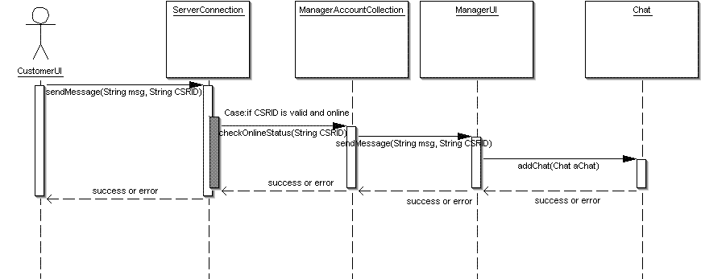

- edit own account information
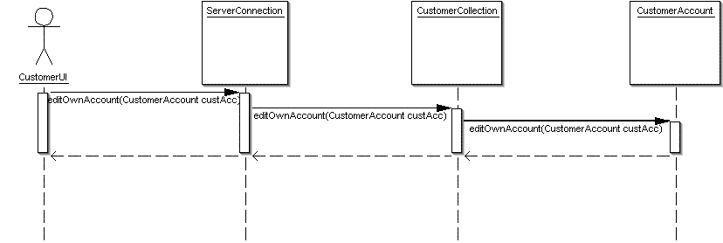

- view own chat log
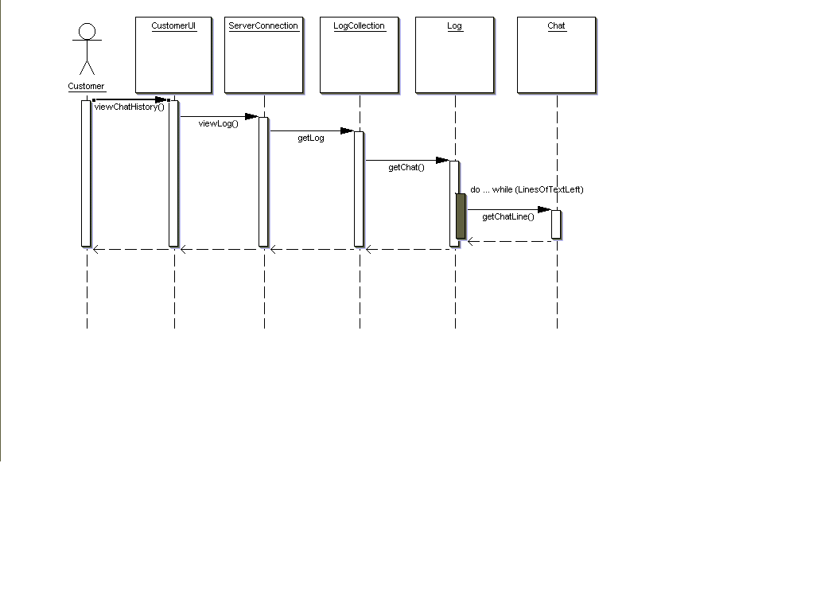
CSR Sequence Diagram

- chat with customer
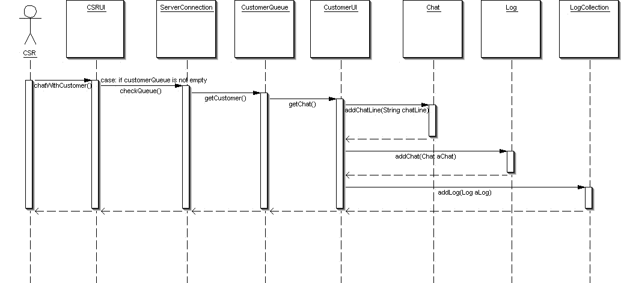

- view logs
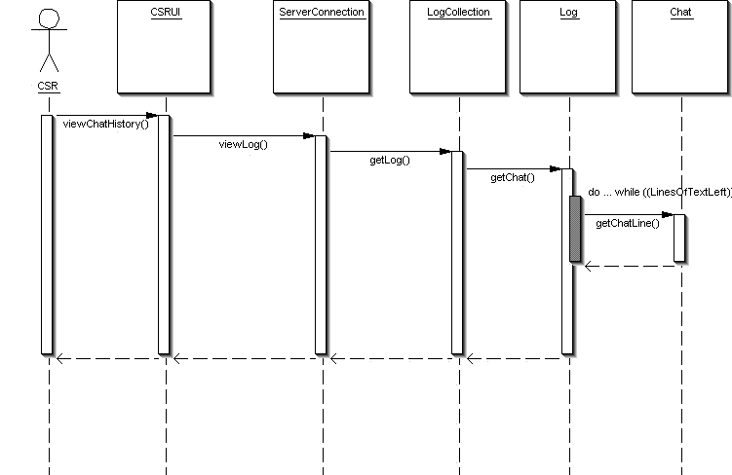

- edit own account
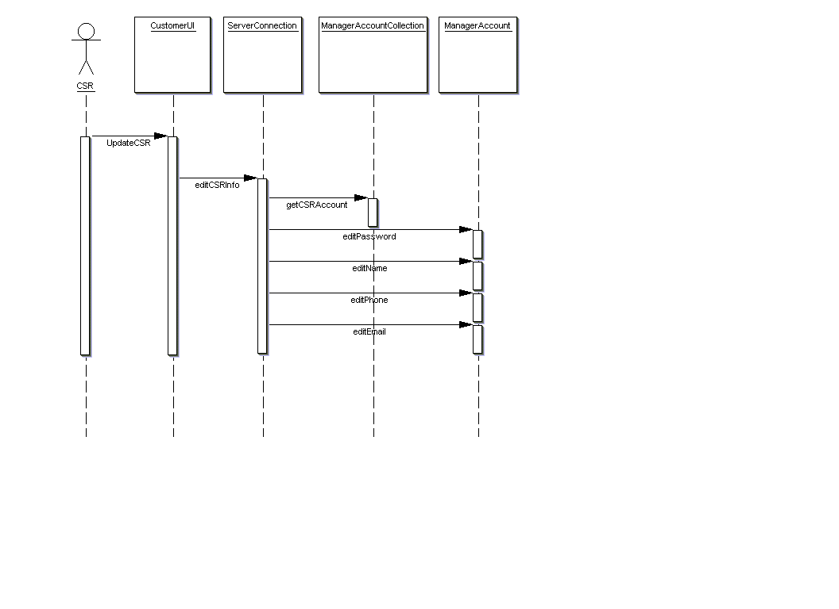

Manager Sequence Diagram

- create/edit/delete CSR
. create CSR
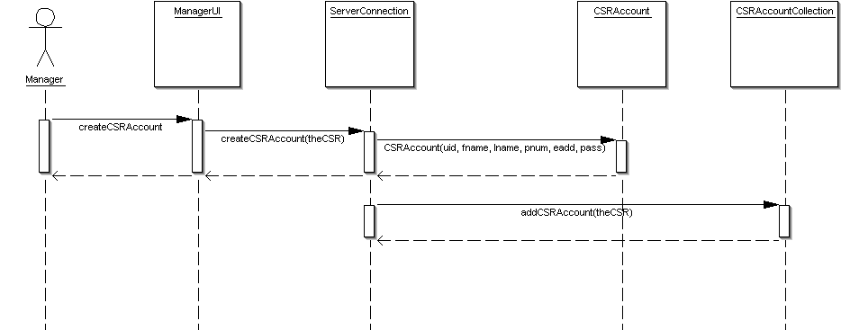

. edit CSR
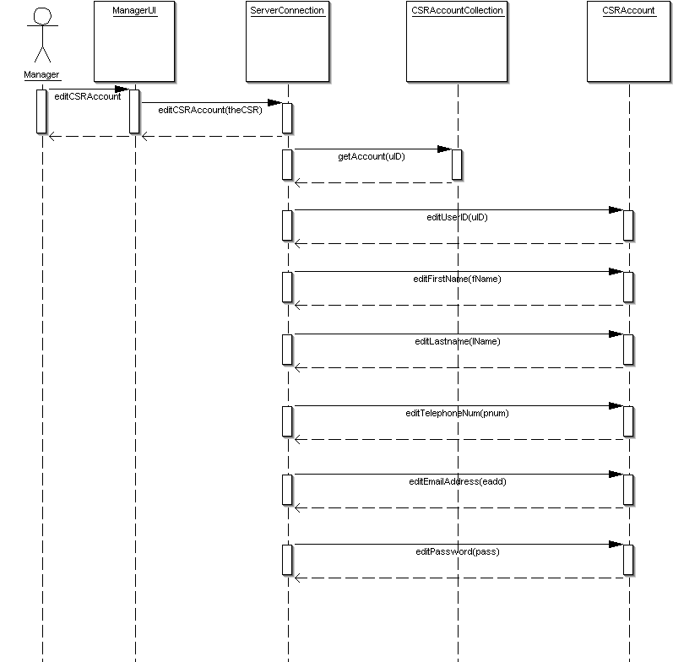

. delete CSR
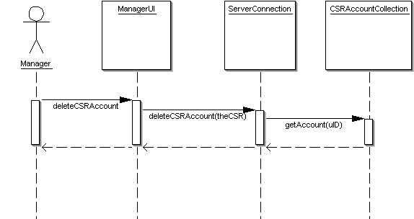

- create/edit/delete Manager
. create Manager
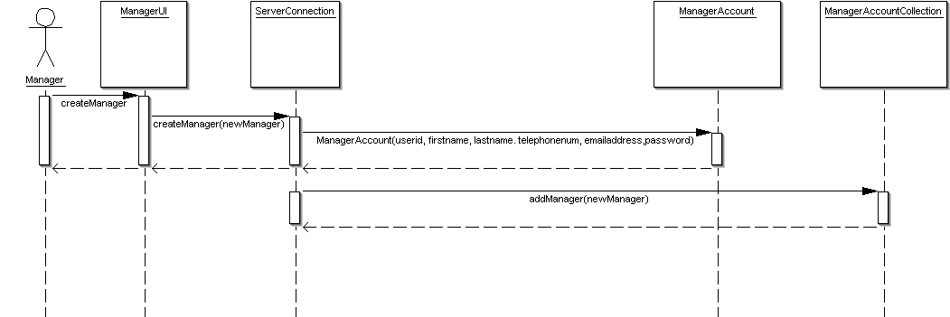

. edit Manager
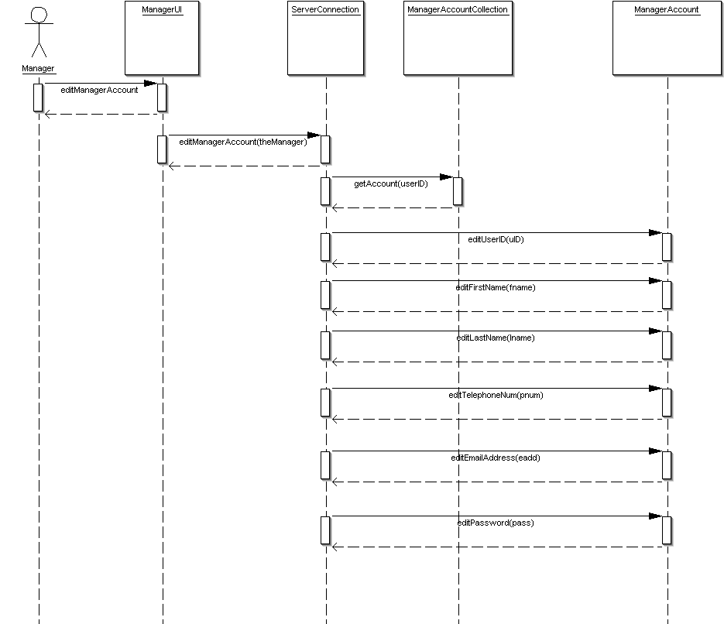

. delete Manager
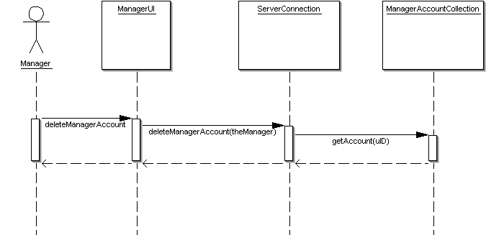

- monitor chat
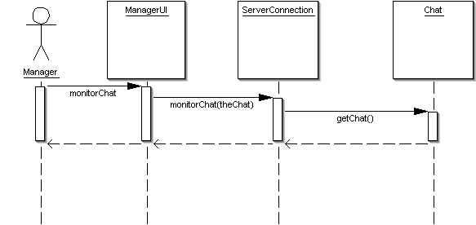

- print report
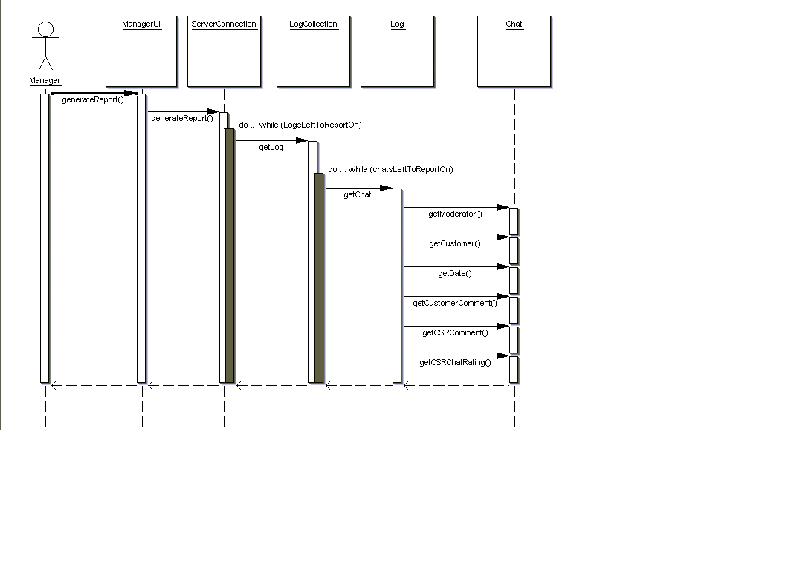

6.1 Application Control

The Application will be designed with ease of use for end user in mind. With this view it was decided that all user classes will share the same basic design with differing functionality. So the starting login webpage will be shared by all users. The Chat application will be divided into three GUIs according to class the user belongs to (Customer/CSR/Manager).

All three GUIs will share the same menu system:

--File Menu
-Customer :: Quit
-CSR :: Accept Chat, Quit
-Manager :: Accept Chat, Monitor Chat, Quit

-Chat History
-Customer :: View own Chat Logs
-CSR :: View own or Customer (enter userid) Chat logs
-Manager :: View any Chat logs (enter userid)

-Account Management
-Customer :: View/Edit own Account information
-CSR :: View/Edit own or Customer (enter userid) Account information
-Manager :: View/Edit (enter userid) any Account Information

Beneath the Menu a Chat Control Panel will be provided. This panel will be shared by all three GUIs. It will contain a text box for message, Send and LogOut buttons.

Under The Chat Control Panel the main messaging window will be located. For CSR and Managerial GUIs this window will contain an additional panel on left side. The additional panel will provide a list of user in queue (CSR/Manager) and list of ongoing chats with ability to monitor (Manager). The Customers GUI will provide only the messaging window.

6.2 Screen 1..n

Login GUI:

-any of the three classes of users and enters their user name and password.
The server will determine the class user belongs to and send appropriate GUI.

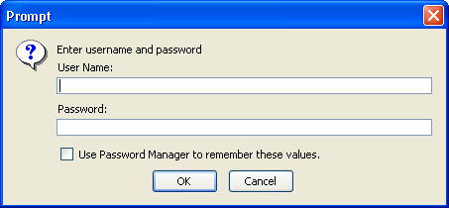

Upon successful authentication one of the following GUIs will be displayed:

Customer GUI:

-basic chat functionality is provided
-the customer has the ability to view/edit Customer’s own account information (Account Management Menu)
-can also view their own Chat Logs (Chat History Menu)

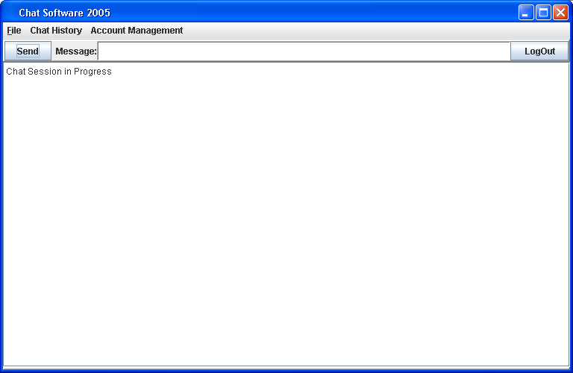

CSR GUI:

- in addition to regular Customer user interface the CSR GUI provides the ability to monitor ongoing Customer Queue and initiate a chat with a customer (next in queue) (click Connect), the ability to edit a Customer’s Account (Account Management Menu and enter userid)

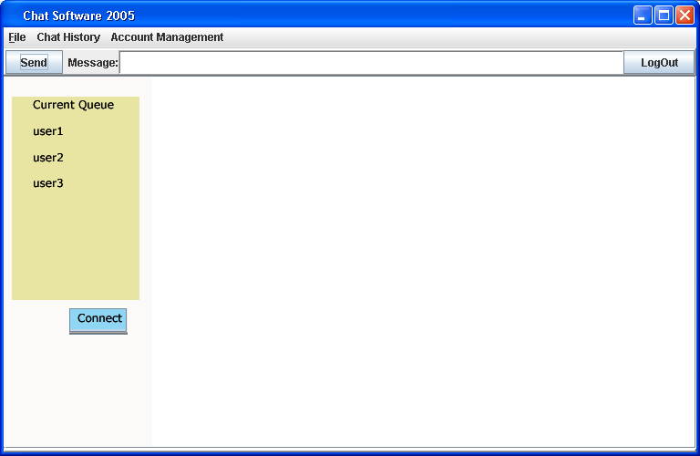

Manager GUI:

-in addition to entire functionality provided by the CSR User Interface, the manager has the ability to monitor live chat conducted by other CSRs, and the manager can edit both CSR and Customer accounts.

-to monitor chat a current chat session between a customer and CSR is selected and monitor clicked.

-to edit CSR/customer accounts the account management menu is selected and user name entered.

